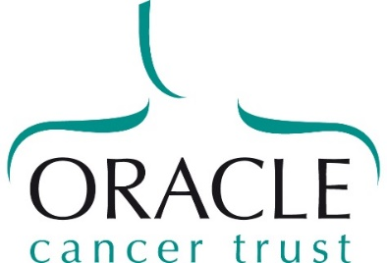
Oracle Cancer Trust
32-36 Loman Street
London
SE1 0EH

t 020 7922 7924
e info@oraclecancertrust.org
www.oraclecancertrust.org

Patron
HRH Princess Alexandra

SUPPLEMENTARY QUESTIONS FOR RESEARCH GRANT APPLICATIONS INVOLVING ANIMALS

Does your research proposal include procedures to be carried out on animals in the UK under the Animals (Scientific Procedures) Act?
Has the necessary approval been given by:
The Home Office (in relation to personal, project and establishment licences)?
Has the necessary approval been given by:
Animal Welfare and Ethical Review Body?
If your project involves the use of animals, what would be the severity of the procedures? MILD/MODERATE/SEVERE
Please provide details of any moderate or severe procedures (no more than 250 words)
Why is animal use necessary; are there any other possible approaches? (no more than 250 words)
Why is the species/model to be used the most appropriate? (no more than 250 words)
Please justify the number of animals to be used per experiment, including details of any sample size calculations and/or statistical advice sought.

