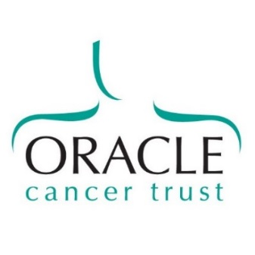
Oracle Cancer Trust
32-36 Loman Street
London SE1 0EH

t 020 7922 7924
e info@oraclecancertrust.org
www.oraclecancertrust.org

Patron
Sir Michael Morpurgo
Gift Aid Declaration
Increase your donation by 25p for every £1 you give at no extra cost to you.

Please tick the box below to Gift Aid your donation
 | I want to Gift Aid my donation of £…………………. and any donations I make in the future or have made in the past 4 years to: ORACLE CANCER TRUST
I am a UK Taxpayer and understand that if I pay less Income Tax and/or Capital Gains Tax than the amount of Gift Aid claimed on all my donations in that tax year, it is my responsibility to pay any difference.

Title |  |  | Initial |  | Surname
House name
Address line 1
Address line 2
Town
County |  |  |  |  |  | Postcode
Tel |  |  |  |  |  | email
Date
Please notify the charity if you:
- Want to cancel this declaration
- Change your name or home address
- No longer pay sufficient tax on your income and/or capital gains

Please send this form with/without your donation to:
ORACLE CANCER TRUST, 32-36 LOMAN STREET, LONDON, SE1 0EH / INFO@ORACLECANCERTRUST.ORG
Oracle Cancer Trust would like to contact you about our work and activities and how you might support us.
To receive his information via email please tick here: ____
If you would prefer NOT to receive this information by post please tick here: ___

PLEASE NOTE YOUR DETAILS WLL NEVER BE PASSED ONTO ANY OTHER ORGANISATION

You can unsubscribe any time by contacting Oracle Cancer Trust at the above address, by calling us on 020 7922 7924
or unsubscribe@oraclecancertrust.org

